Task 01:

Builder

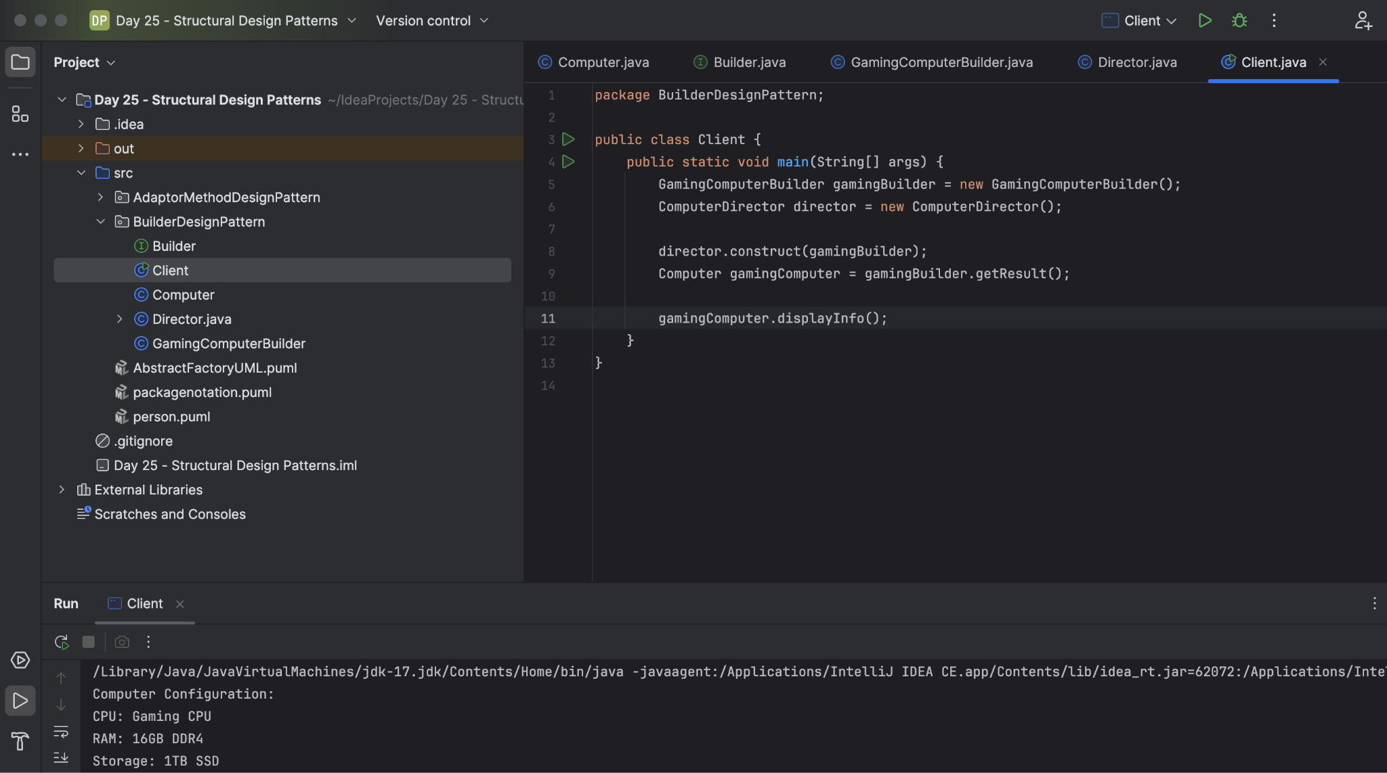

Task 02:

Adaptor Design Pattern

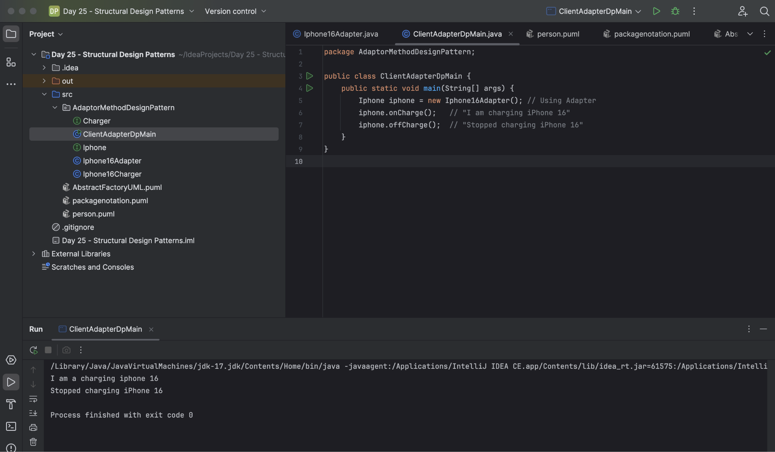

Task03:
Create a class diagram in uml..

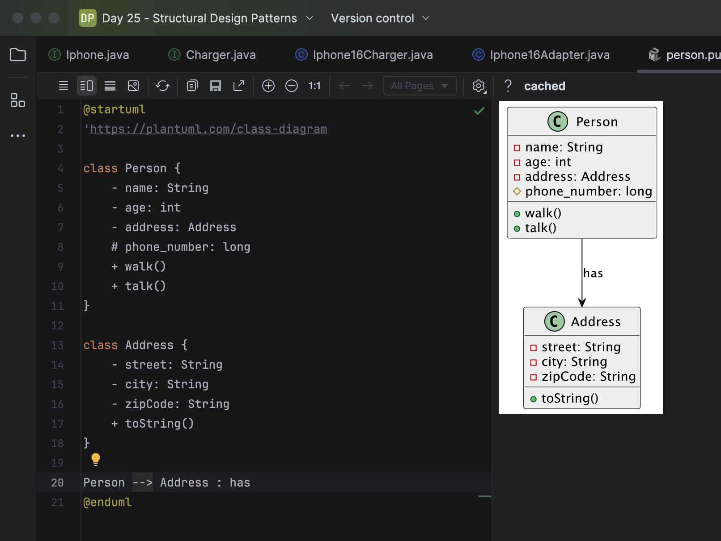

Task 04:

What are the commonly used visibility Notations in class diagrams?

Public (+):
Members with public visibility are accessible from anywhere, including other classes and packages.
Private (-):
Members with private visibility are only accessible from within the same class.
Protected (#):
Members with protected visibility are accessible from within the same class and its subclasses (child classes).
Package (~):
Members with package visibility are accessible only from classes within the same package.

Task 05:

What do you know about Parameter Directionality?

Parameter directionality in a UML Class Diagram specifies the flow of information for parameters within an operation (method). It indicates whether a parameter acts as an input, an output, or both, relative to the operation's execution.

- in - eg: +operationName(in parameterName: parameterType)
- out - eg: +operationName(out parameterName: parameterType)
- Inout - eg: +operationName(inout parameterName: parameterType)

Example:
Consider a BankAccount class with an updateBalance operation:

+updateBalance(in amount: Money, out newBalance: Money, inout transactionLog: String)

Task 06:

Class Diagram Relationships:

Class diagram relationships in UML represent how classes interact with each other. The main types of relationships are: inheritance, association, aggregation, composition, and dependency. These relationships are visually represented with different types of lines and symbols

Task 07:

Package notation

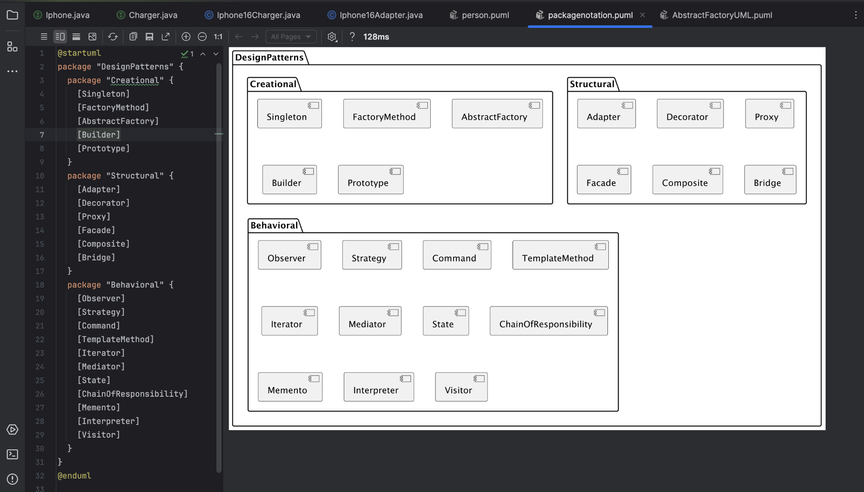

Task 08:
what is state notation .. initial and final ?

In Object-Oriented Analysis and Design (OOAD), states are represented using a UML state machine diagram, which is a type of behavioral diagram. These diagrams use specific symbols to denote different aspects of an object's lifecycle and transitions between states. Key elements include initial states (filled black circle), states (rounded rectangles), transitions (arrows), and final states (filled black circle enclosed in a circle).

Initial State:
Indicated by a solid black circle, this signifies the starting point of the object's lifecycle.

Final State:
A filled black circle inside a larger circle, the final state indicates the end of the object's lifecycle.

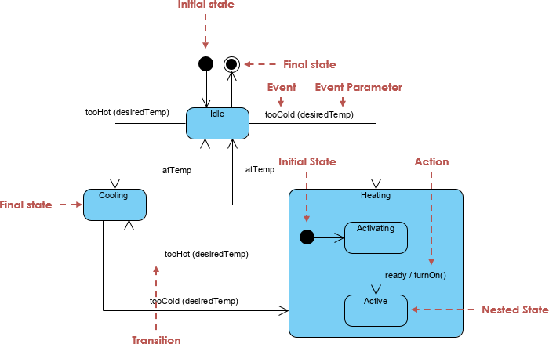

Home task01:

Facade code:

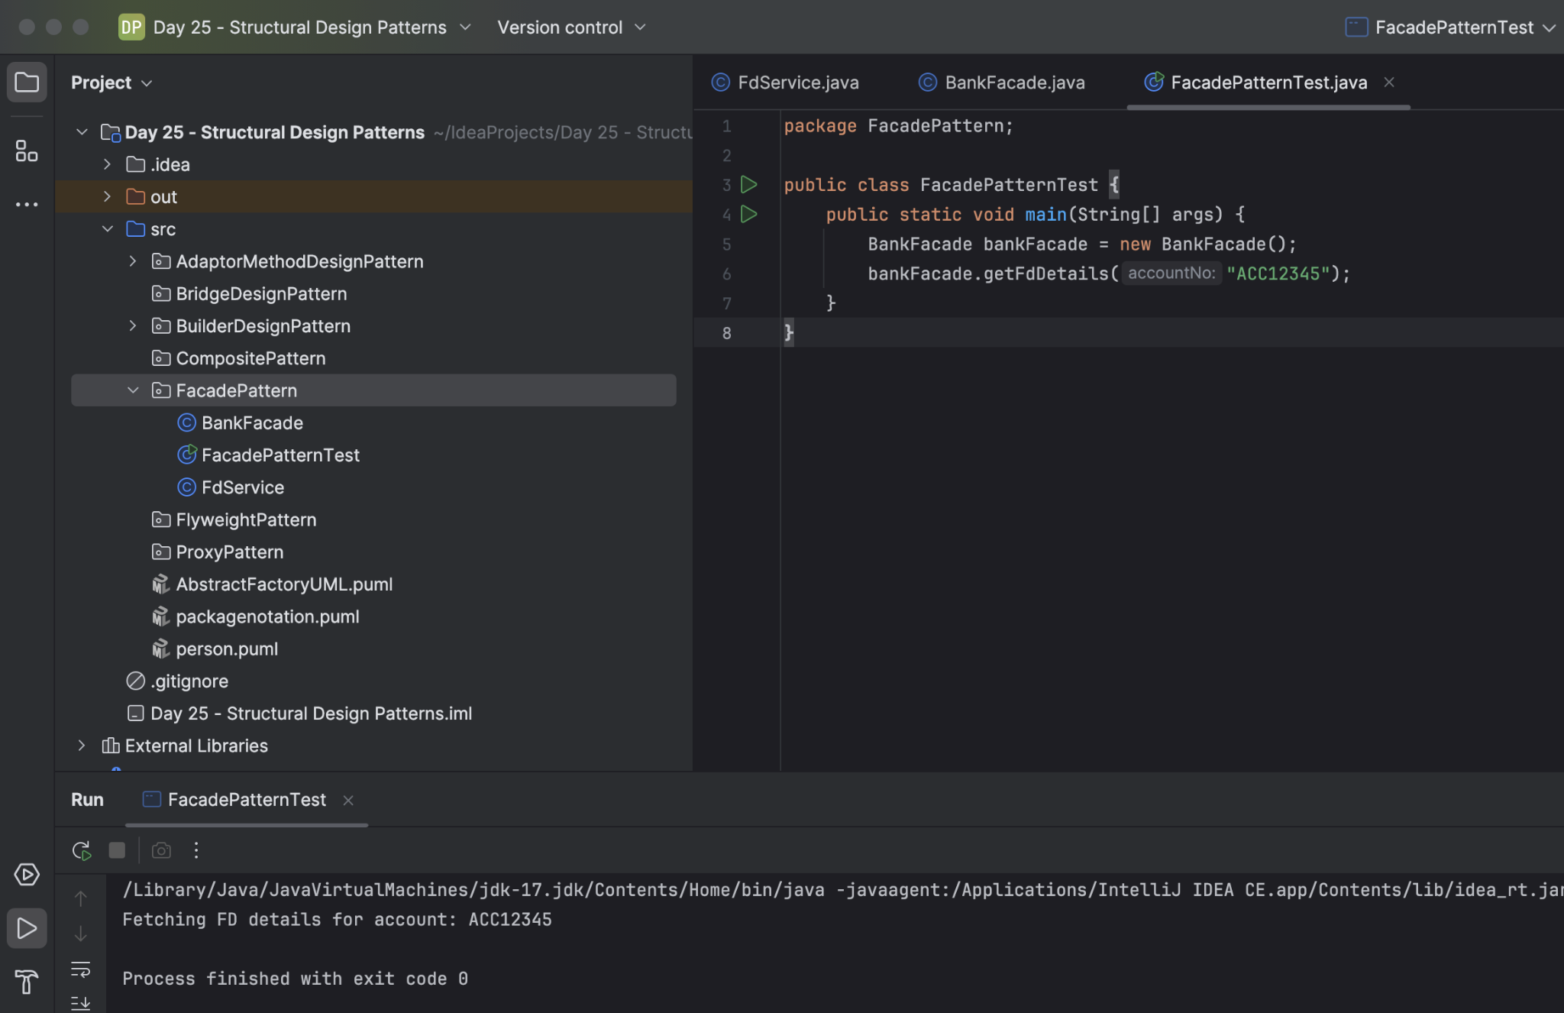

Home task 02:

Composite Method Design Patteren:

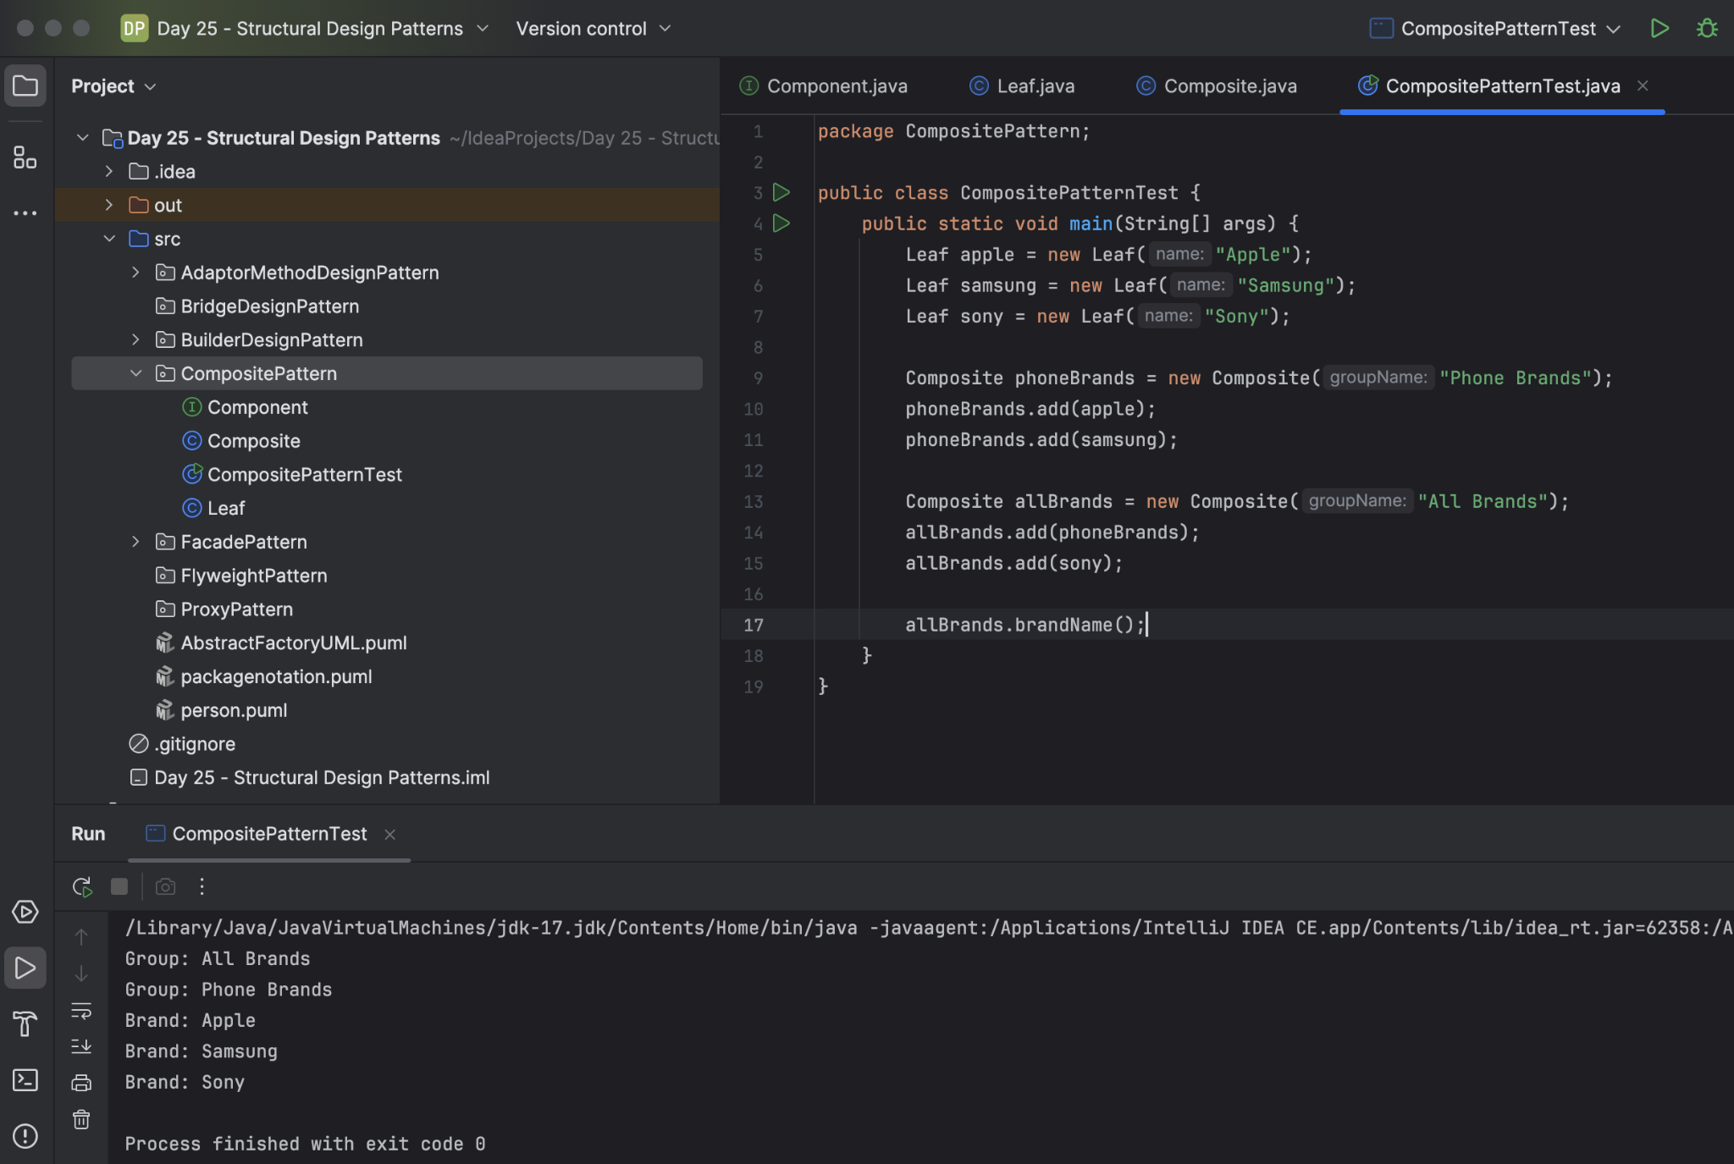
Home Task 03:

Proxy:

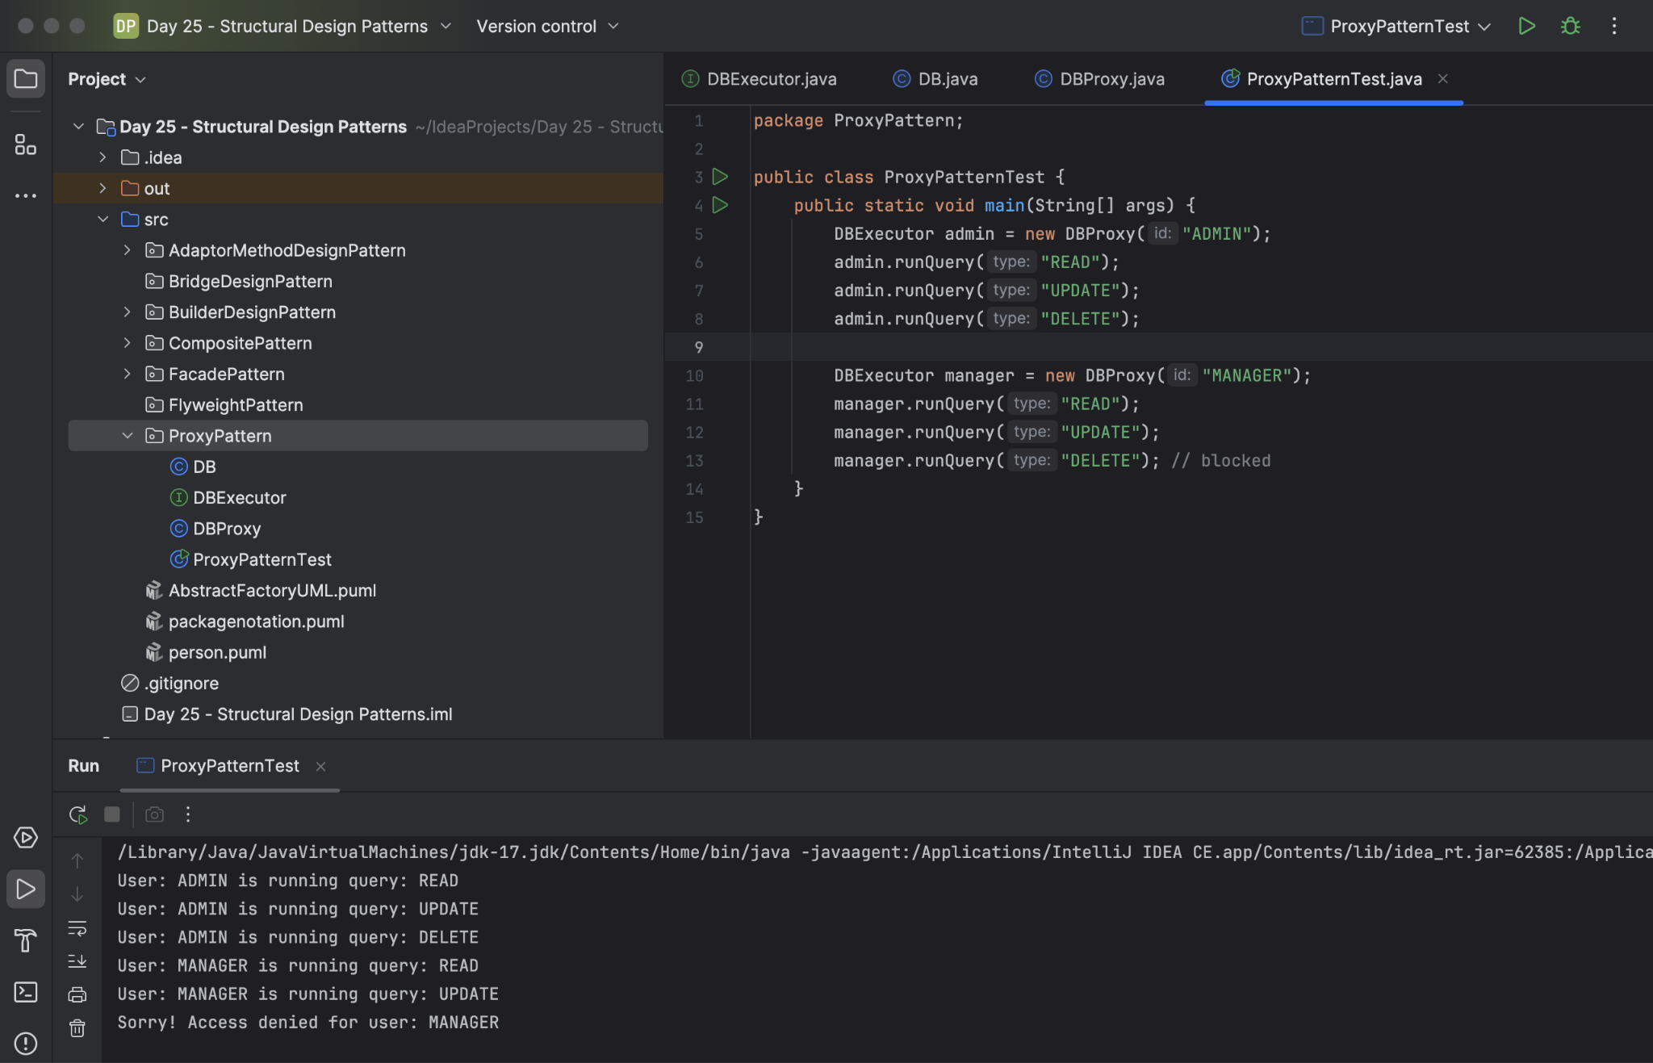

Hometask 04:
Flyweight

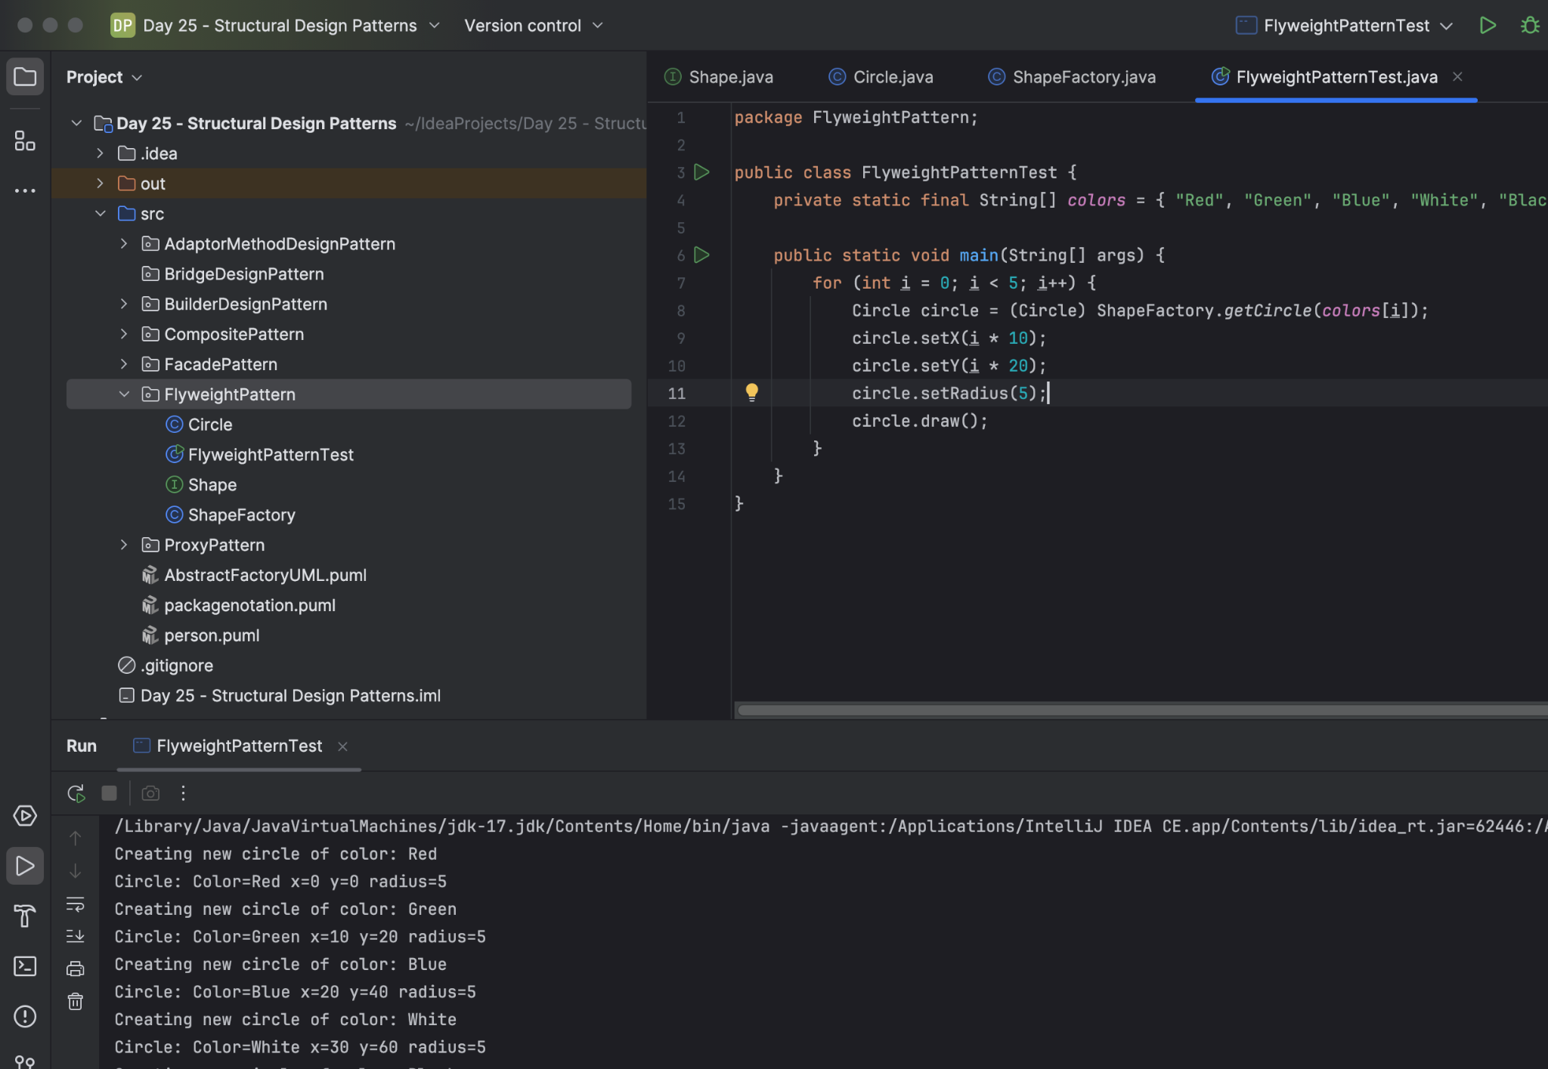

HomeTask 05:
Bridge

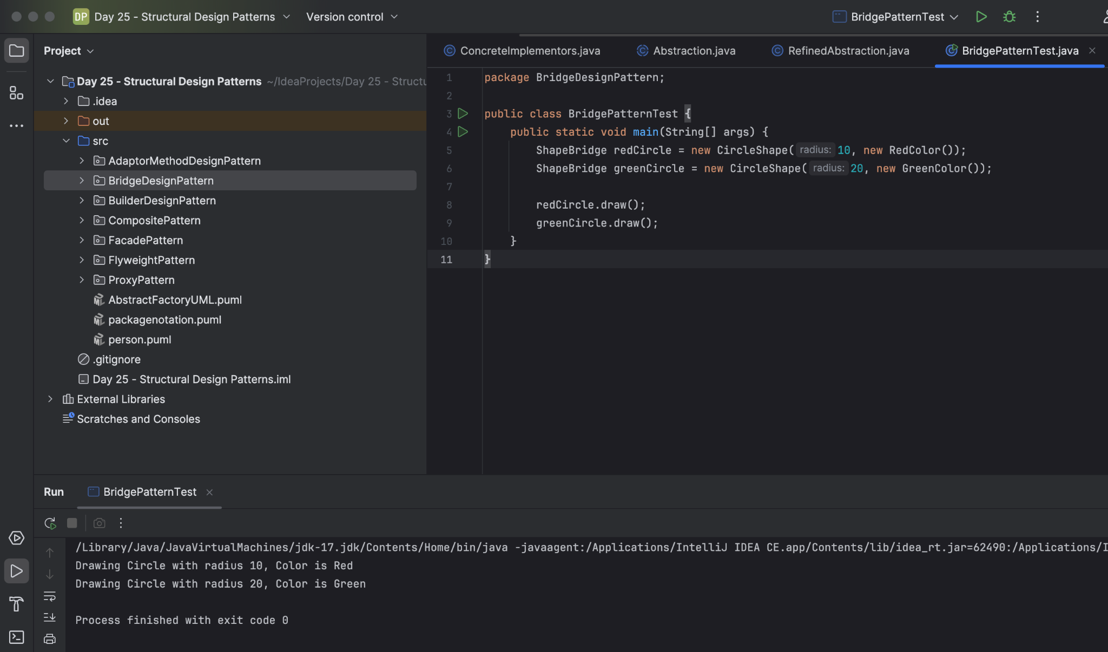

Home Task 06:

Develop the below prototype method DP..

